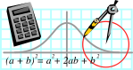  Rossmoyne SHS  Mathematics  Department | MATHEMATICS SPECIALIST 3A | Semester 1 2011  EXAMINATION

NAME:
TEACHER (circle): Mr White Ms Rigelsford
Ms Belonogoff Ms Robinson Mr Jones

Section One:
Calculator-free

Time allowed for this section
Reading time before commencing work: 5 minutes
Working time for this section: 50 minutes

Material required/recommended for this section

To be provided by the supervisor
This Question/Answer Booklet
Formula Sheet

To be provided by the candidate
Standard items: pens, pencils, pencil sharpener, eraser, correction fluid, ruler, highlighters

Special items: nil

Important note to candidates
No other items may be used in this section of the examination. It is your responsibility to ensure that you do not have any unauthorised notes or other items of a non-personal nature in the examination room. If you have any unauthorised material with you, hand it to the supervisor before reading any further.

Structure of this paper

Section | Number of questions available | Number of questions to be answered | Working time (minutes) | Marks available
Section One:  Calculator-free | 7 | 7 | 50 | 40
Section Two:  Calculator-assumed | 11 | 11 | 100 | 80
 |  |  |  | 120

Instructions to candidates

1. The rules for the conduct of Western Australian external examinations are detailed in the Year 12 Information Handbook 2011. Sitting this examination implies that you agree to abide by these rules.

2. Answer the questions in the spaces provided.

Section One: Write answers in this Question/Answer Booklet. Answer all questions.
Show all your working clearly. Your working should be in sufficient detail to allow your answers to be checked readily and for marks to be awarded for reasoning. Incorrect answers given without supporting reasoning cannot be allocated any marks. For any question or part question worth more than two marks, valid working or justification is required to receive full marks. If you repeat an answer to any question, ensure that you cancel the answer you do not wish to have marked.

It is recommended that you do not use pencil, except in diagrams.

3. You must be careful to confine your responses to the specific questions asked and to follow any instructions that are specific to a particular question.

4. Spare pages are included at the end of this booklet. They can be used for planning your responses and/or as additional space if required to continue an answer.
- Planning: If you use the spare pages for planning, indicate this clearly at the top of the page.
- Continuing an answer: If you need to use the space to continue an answer, indicate in the original answer space where the answer is continued, i.e. give the page number. Fill in the number of the question(s) that you are continuing to answer at the top of the page.

QUESTION | MARKS AVAILABLE | STUDENT MARK
1 | 7
2 | 3
3 | 3
4 | 9
5 | 8
6 | 6
7 | 4
TOTAL | 40

The following information may be useful to answer questions in this examination.

 | 0⁰ | 30⁰ | 45⁰ | 60⁰ | 90⁰
Sin | 0 |  | 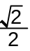 | 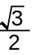 | 1
Cos | 1 |  |  |  | 0
Tan | 0 | 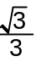 | 1 | 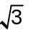 | undefined

The solution to 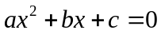 is 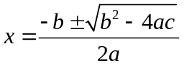

Question 1

[3, 2 & 2 = 7 marks]
i) Use an algebraic method to solve for exact values of .
a) 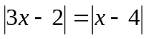

b) 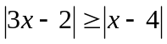

ii) Determine the value of the constant in the inequality
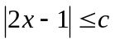 for which the solution set is 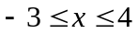

Question 2

[3 marks]
Simplify the following.

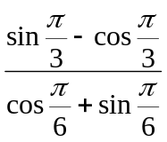

Question 3
[3 marks]
The diagram below shows a circular entertainment area. It has a paved hexagonal area with plants growing in the garden (shown as the shaded areas). If the radius of the circle is 6 m show that the area of the garden is
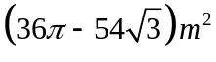.
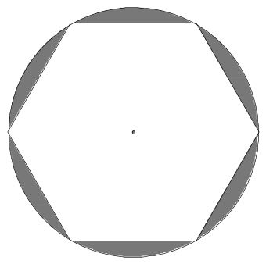

Question 4
[2, 2, 1, 2 & 2 =9 marks]
i) Simplify each of the following.

a) 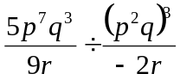

b) 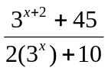

ii) Let 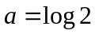 and 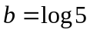. Express each of the following in terms of and and in the absence of log terms.

a) 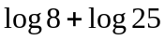

b) 3

c) 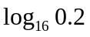
Question 5
[2, 3 & 3 =8 marks]

Let vector 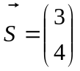 and vector 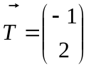. Determine the following in exact form:

a) 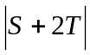

b) a vector parallel to but 5 times the length of .

c) the values of and  given that 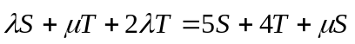

Question 6
[1, 1, 2 & 2 =6 marks]
ABC is a triangle with 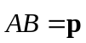 and 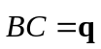. In addition M divides AB in the ratio 1:3 and N divides BC in the ratio 2:3.

- Draw a diagram that represents the information given.

Q6 Continued
b) Find in terms of p and q vector expressions for :

i) 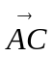

ii) 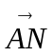

iii) 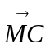

Question 7
[4 marks]
The function 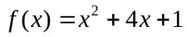 has the domain 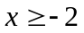 and the range 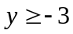.
Determine the inverse function 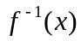,simplified, stating its domain and range.

End of Section 1
Working out space
Please indicate on question if this space is used.

End of booklet

